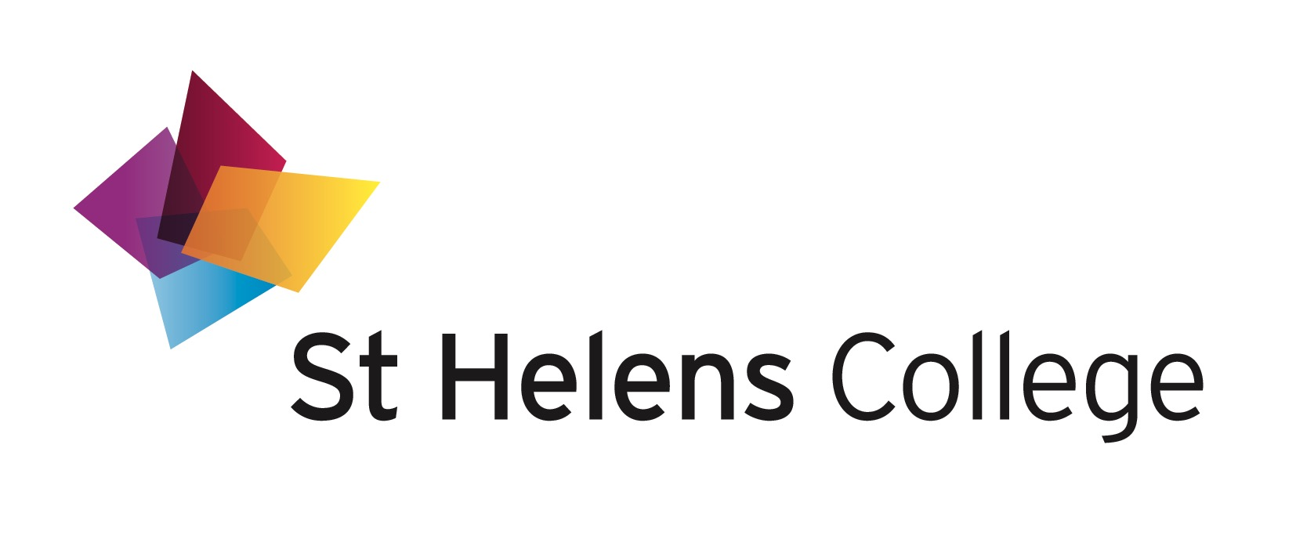
ST HELENS COLLEGE CORPORATION
MEETING OF THE AUDIT COMMITTEE HELD AT
10.00 am ON MONDAY 27 NOVEMBER 2017 IN THE BOARD ROOM,
TOWN CENTRE CAMPUS

M I N U T E S
MEMBERSHIP:

* Mr P Christian
Ms D Charnock
* Mr J Middlehurst (Chair)
* Mr K Sanderson
Vacancy

IN ATTENDANCE:

Mr J Creed, ICCA
Mr I Leverson, KPMG
Dr J Burford, CEO
Mr S Arnfield, Director of Finance
Mrs C Jones, Clerk to the Corporation

1 DECLARATIONS OF INTEREST

There were no declarations of interest notified.

2 APOLOGIES FOR ABSENCE

Apologies for absence were received from Ms D Charnock and Mr R Molloy.

3 NOTIFICATION OF URGENT BUSINESS

There were no items of urgent business notified.

4 MINUTES OF THE PREVIOUS MEETING HELD ON 10 OCTOBER 2017

The minutes of the above meeting were agreed and signed as a correct record.

5 MATTERS ARISING

a Minute 4a p1 – Serious incident near to STEM Centre
The CEO confirmed that the police investigation was continuing.

b Minute 10 P4 – KPMG’s Annual External Audit Planning Memorandum.
The Director of Finance reported that this action has been covered as part of the merger process.

6 AUDIT LOG OF INTERNAL AUDIT RECOMMENDATIONS BROUGHT
FORWARD FROM PREVIOUS MEETING

Mr S Arnfield, Director of Finance, presented the audit log of internal audit recommendations brought forward from the previous meeting, which was accepted by the Audit Committee, with no issues identified.

7 REPORT AND FINANCIAL STATEMENTS: YEAR-ENDED 31 JULY 2017

The Director of Finance presented the Report and Financial Statements for the Year-Ended 31 July 2017 for information, which had been approved by the Resources Committee at the meeting held on 24 November 2017 and recommended for approval by the Corporation at the meeting scheduled on
4 December 2017, subject to a couple of identified narrative amendments.

A number of amendments to the narrative of the accounts had been identified, which mostly reflected reference to the incorrect years of account.

The restructuring costs were highlighted and it was confirmed that these refer to just St Helens College. The reference to ‘Group’ was confirmed as being the St Helens College consolidated Group accounts, which included Skills NW.

The Report and Financial Statements for the Year-Ended 31 July 2017 were noted by the Audit Committee.
ACTION: Director of Finance to amend the Financial Statements as agreed by the Committee

8 AUDIT HIGHLIGHTS MEMORANDUM AND MANAGEMENT LETTER:
YEAR-ENDED 31 JULY 2017

Mr Leverston from KPMG presented the Audit Highlights Memorandum and Management Letter 31 July 2017, which represents the findings of the audit that is undertaken as part of the audit of accounts of the College and the regularity audit.

KPMG reported their thanks to the Director of Finance and the Finance Team for their significant work throughout what has been a more difficult audit relating to both St Helens College and Knowsley Community College.
It was noted that there were no significant concerns or audit issues arising from the audit work undertaken at the College and that it was anticipated that KPMG will be able to provide clean audit opinions on both the financial statements and regularity audits, following the approval of the financial statements by the Corporation.
Following a question from the Committee, it was noted that the deadline for signing the accounts was 31 December 2017, and the format of the accounts within a merger situation was summarised.
The position relating to the Triennial review of the Merseyside Pension Fund was discussed in detail by the Audit Committee.

The Committee asked about this year’s student recruitment position at both Colleges, which it was confirmed was most disappointing at Knowsley Community College. St Helens College was slightly behind target on HE enrolments, but this position is been mirrored across the FE sector.
The Audit Highlights Memorandum and Management Letter for the year ended
31 July 2017 was accepted by the Audit Committee, and the report would be presented to the Corporation at the meeting scheduled on 4 December 2017.

The Audit Committee also thanked the Director of Finance and the Finance Team for their work this year in what has been a difficult merger year.

9 REGULARITY AUDIT – SELF-ASSESSMENT REPORT QUESTIONNAIRE

The Director of Finance presented the Regularity Audit: Self-Assessment report questionnaire, which is part of KPMG’s regularity audit and supports the financial statements audit review process.

Following a question from the Committee, the status of the now ceased Gamble Education Charity Trust would be clarified with Eversheds.
ACTION: Director of Finance to clarify the legal position of the Gamble Education Charity Trust with Eversheds

The Audit Committee accepted the Regularity Audit Self-Assessment report as presented, subject to the year to be included to which it refers (ie 2016/17),
which would be signed by the CEO/Principal and by the Chair of the Corporation.
ACTION: Director of Finance to include the year of account in the title of this report

10 INTERNAL AUDIT REPORT – ADDITIONAL LEARNER SUPPORT

Mr J Creed from ICCA presented the above internal audit report, reporting that the
review had identified 2 low audit recommendations, with the management
responses noted by the Committee.

Based on this assessment, it was reported that ICCA were able to provide
management and the Audit Committee with Substantial Assurance that the areas
of the control environment tested during the audit were designed and operating
effectively, with no significant weakness identified.

The Committee requested that reports on progress of the Learner Support Fund
should be presented to SLT twice per year to monitor progress.
Action: Director of Finance to oversee the presentation of Learner Support Fund progress reports twice per year to SLT
The Audit Committee accepted the internal audit report relating to Additional
Learner Support, as presented.

11 DRAFT ANNUAL REPORT OF THE AUDIT REPORT 2016/17

The Clerk presented the draft annual report of the Audit Committee for 2016/17, which was primarily based on ICCA’s annual report, as outlined within the previous agenda item.

The Annual Report summarises the work of the Audit Committee over the period 2016/17 and provides the Corporation, and the CEOl as the Chief Accounting Officer, with an opinion on the adequacy and effectiveness of the College’s internal control, governance and risk management systems.

It was agreed that the overall opinion of the Audit Committee to the Corporation was as follows:

“Based on the work undertaken during the year, and the implementation by management of previous internal audit recommendations, we can provide the Audit Committee and Corporation with Reasonable Assurance that St Helens College’s governance, risk management, and systems of internal control were operating adequately and effectively, and that there were no instances where any breakdown of control resulted in a material discrepancy.
In our opinion, the College has adequate and effective governance, risk management, and systems of internal control in place to manage the achievement of its objectives and securing economy, efficiency and effectiveness”.

The Clerk apologised for omitting to include within the above statement that there were “No significant control issues were identified in 2016/17 as a result of work undertaken”, and this would be included within a revised annual report to be presented to the Corporation on 4 December 2017.

The Committee discussed the third term of reference of the Audit Committee which refers to informing the Corporation on the provision of any additional services by the financial statements, regularity and the audit and assurance providers, and to explain how independence and objectivity have been safeguarded, and it was agreed that this should form part of the annual report to the Corporation at the next Corporation meeting.

The Audit Committee endorsed the Annual Report of the Audit Committee, subject to the above amendments, which would be presented to the Corporation at the meeting scheduled on 4 December 2017.
ACTION: Chair of Audit Committee to present the amended Draft Annual Report of the Audit Committee to the Corporation

12 ANNUAL STATEMENT OF REPORTED INCIDENTS OF FRAUD/ WHISTLEBLOWING

The Clerk reported that there were no reported incidents of fraud or whistleblowing made in 2016/17, which was accepted by the Audit Committee.

13 ANNUAL GIFTS AND HOSPITALITY RETURN

The Clerk presented the annual Gifts and Hospitality Register for 2016/17 which was accepted by the Audit Committee.

14 RISK REGISTER: PROGRESS REPORT

The Director of Finance reported that there were no changes to report to the Risk Register since the previous review. There will be a joint risk register developed post-merger that will be presented to the new Audit Committee.

The Committee asked about training for the risk management group, and this would be addressed as part of the overall revised internal committee structure.

The Risk Register progress report was accepted by the Audit Committee.

15 LETTER FROM CEO OF ESFA

The CEO presented a letter that had been received from the ESFA which raised the important matter of standards of governance and accountability in colleges in the sector, the details of which were noted by the Audit Committee. This letter had also been reviewed by last week’s meeting of the Resources Committee. It was noted that a series of external business planning development session will be scheduled, commencing with the Executive Team on 5 December 2017.

16 URGENT BUSINESS (AS NOTIFIED UNDER MINUTE NUMBER 3 ABOVE)

There were no items of confidential business notified.

17 DATE AND TIME OF NEXT MEETING: As this would be the final meeting of the SHC Audit Committee, retiring members were sincerely thanked for their services to the work of the Committee.

Mr J Creed from ICCA and Mr Leverston from KPMG was asked if there were any issues that they wished to raise without the presence of College Staff, with no issues raised. Similarly, the Audit Committee had no issues to raise with the auditors without the presence of College staff.

KEY OUTCOMES:

INTERNAL AUDIT REPORTS: The Audit Committee accepted 1 internal audit reports in the area of Additional Learner Support.

REPORT AND FINANCIAL STATEMENTS: YEAR-ENDED 31 JULY 2017: The Report and Financial Statements for the Year-Ended 31 July 2017 were noted by the Audit Committee, with some slight narrative amendments identified.

AUDIT HIGHLIGHTS MEMORANDUM AND MANAGEMENT LETTER: YEAR ENDED
31 JULY 2017: The Committee accepted the Audit Highlights memorandum and Management Letter for the year-ended 31 July 2017 and recommended acceptance to the Corporation, subject to some slight amendment.

REGULARITY AUDIT: SELF-ASSESSMENT REPORT QUESTIONNAIRE: The Audit Committee accepted the Regularity Audit Self-Assessment report to be signed by the Chair of the Corporation and the CEO/Principal.

ANNUAL REPORT: The Audit Committee recommended to the Corporation, and to the CEO as the Chief Accounting Officer of the College, the Annual Internal Audit report for 2016/17 from the Audit Committee.

